Fraster launches self-adhesive felt pieces with acoustic effect for functional wall decoration
BRIX – Peace by Piece may be experienced at Fraster’s stand (A19:30) at the Stockholm Furniture Fair® where you will also have the opportunity to receive a small sample of the 10.5-milimetre-thick pieces and a chart showing the 12 designs.
When the Stockholm Furniture Fair® opens its doors to visitors on 5 February 2019, they will experience an entirely new and functional way of decorating the walls of office landscapes, reception areas, meeting rooms, hallways and the like.
The name of the new product is BRIX – Peace by Piece and is launched by the Danish company Fraster.
Creative freedom
BRIX is made up of a range of felt pieces in nine different shapes. Fraster has used the shapes to create twelve creative designs, which may all be multiplied indefinitely to cover the desired wall area. Moreover, all pieces are available in 35 different colours which means that the design options are virtually infinite.
Interior decorators as well as vendors and customers may let their creativity loose with the digital paint book on Fraster’s website. Here, you can chose the desired design and the desired dimensions and then experiment with various combinations of the 35 colours.
The price of a BRIX decoration is calculated solely by area and is therefore not affected by the number of different shapes and colours used.
Absorbs sound
The pieces in the BRIX range are made from 5-milimetre wool felt with a back cover made from 5.5-milimetre PET-felt. This combination adds an acoustic function to the pieces which contributes to softer and more pleasant acoustics in the room. This is primarily due to the soft felt surface preventing the sound of steps and other noise being echoed at the same volume as that of a hard and smooth surface.
Easy to install
BRIX is fitted with a double-adhesive tape on the back. Moreover, the felt pieces are supplied with simple installation instructions for the chosen design which means that the entire decoration may be effortlessly installed by the vendor’s own fitters.
BRIX – Peace by Piece may be experienced at Fraster’s stand (A19:30) at the Stockholm Furniture Fair® where you will also have the opportunity to receive a small sample of the 10.5-milimetre-thick pieces and a chart showing the 12 designs.
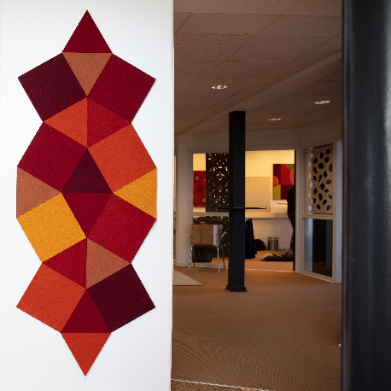
For more information, please contact
Trine Neve, Head of Design
Email: neve@fraster.dk
Mobile: +45 23 20 51 57

Frasters thoughts about felt rugs

Fraster felt rugs may be experienced at Fraster’s stand (A19:30) at the Stockholm Furniture Fair®
Try exploring your own home. Look at the rooms with new eyes. Let your eyes wander across the floors. Then, let your creativity run free.

Who says that area rugs are only suitable for under dining and coffee tables?
And who says that they have to be square? Or round? Who has limited your individuality to a narrow palette of colours and patterns? And what should keep you from thinking new thoughts about rugs? From creating new exciting rooms inside rooms? Marking special spots? Highlight your favourite corner? Underline a good feeling? Who should keep you from creating a great home?

Fraster’s collection of felt rugs embraces endless shapes and sizes - and 35 beautiful colours in merino wool.

Fraster’s felt rugs can be tailor made in exact dimensions for you, in exact the design you wish and in the colours you wish.

Fraster’s felt rugs are made in pure merino wool, adding character and warmth to the room, and is easy to maintain.

Fraster’s felt rugs have many good qualifications for instance is felt great for sound absorption, enabling improved acoustics.

Fraster’s felt rugs are available in the exact dimensions you need, making it possible for you to order felt rugs and runners in lengths, which other rug manufacturers may not be able to offer
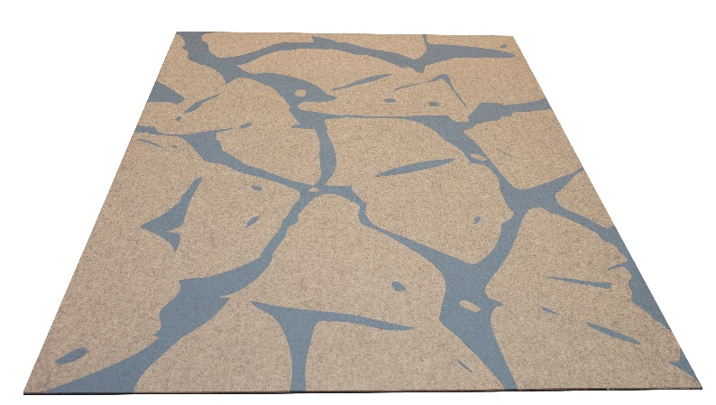
Further information
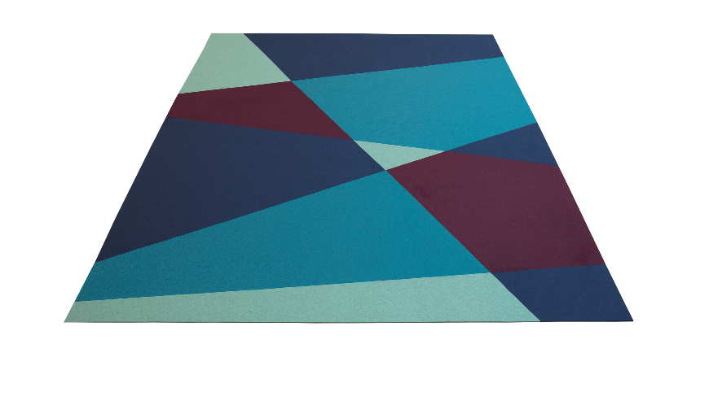
Head of design Trine Neve
E-mail: neve@fraster.dk
Mobil: +45 23 20 51 57
